National Research University Higher School of Economics Faculty of Computer Science

Programme ‘Master of Data Science’

MASTER’S THESIS

Russian Sign Language Dactyl Recognition from Video in Dactyl Education Application

Student:

Tsimafei Akulich

Supervisor:

PhD, Associate Professor, Ilya Makarov

Moscow, 2022

ABSTRACT

Sign language is the main way for deaf people and people with hearing impairment to communicate between each other and with family members who do not have these disabilities.

Most people do not know sign language, so the automation of sign language interpretation is one of the hot topics, progress in this area will simplify communication between people with hearing impairments and people without them.

This paper focuses on the recognition of Russian sign language dactyls. There are papers on this topic with good results on recognition of static dactyls and some dynamic ones, represented as static, using deep convolutional neural networks. In this master's thesis, which is a group project created by students Tsimafei Akulich and Olga Vasileva, we have received more accurate results on static dactyls recognition and implemented dynamic dactyl recognition from video. In our approach, we use hand pose estimation, the author's algorithm for feature generation that considers the anatomical characteristics of a hand, and one of the classical machine learning algorithms for classification.

To train the model we created our own dataset consisting of more than 66 thousand images. To make our work complete, we created the dactyl education application with an interactive mode for recognizing the dactyl shown by the user.

**TABLE OF CONTENTS**

ABSTRACT 2

DEFINITIONS, DESIGNATIONS AND ABBREVIATIONS 4

INTRODUCTION 5

GENERAL DESCIPTION OF A TEAM PROJECT 7

CHAPTER 1 OVERVIEW OF AVAILABLE RESULTS AND CURRENT APPROACHES 9

CHAPTER 2 DATASET 13

2.1 Russian dactyl alphabet 13

2.2 Dataset concept 14

2.3 Test dataset creation 18

CHAPTER 3 PIPELINE 19

3.1 Hand pose estimation and landmarks 19

3.2 Feature generation 22

3.3 Model selection for dactyls classification 23

3.4 Results comparison and selection of the best model 27

CHAPTER 4 TESTING THE MODELS UNDER DIFFERENT CONDITIONS 28

4.1 Distance 28

4.2 Illumination level 29

4.3 Rotation 30

4.4 Color of clothes (background) 32

CHAPTER 5 APPLICATION 33

5.1 Application description 33

5.2 Application flow 34

5.3 Application operation modes 36

5.3.1 Simple detection and classification 36

5.3.2 Correct dactyl 37

5.3.3 Word guessing mode 38

CONCLUSION 39

REFERENCES 40

APPLICATIONS 42

DEFINITIONS, DESIGNATIONS AND ABBREVIATIONS

**RSL** — Russian sign language

**SL** — sign language

**RDA** — Russian dactyl alphabet

**ML** — machine learning

INTRODUCTION

About 13 million people in Russia have some degree of hearing loss. The degree of hearing loss can range from mild hearing loss to total deafness. Learning the Russian sign language (RSL) begins with learning the Russian dactyl alphabet (RDA).

Children with congenital hearing loss learn the basics of grammar by spelling entire words using RDA before they even learn to write. Not only hearing-impaired people, but their relatives as well learn RSL, it allows them to maintain communication.

The automation of sign language (SL) interpretation is one of the actual topics, progress in this area will simplify communication between people with hearing impairments and people without them.

The dactyl recognition process is a standard machine learning pipeline: collecting and preprocessing data, splitting into samples, training the model, and examining the quality of the model on test data, the task is a multiclass classification. At this time, the available approaches using deep convolutional neural networks allow to recognize static RSL dactyls, the maximum obtained overall accuracy is 78%.

In our project the recognition of dactyls, both statistic and dynamic, is implemented with a fairly high accuracy, the overall accuracy on the test sample is 95.75%. In order to get good results, first we created a dataset ourselves, because the available datasets contain a small number of images, the quality of some images is low. The training sample consists of more than 47 thousand images, the test sample consists of almost 19 thousand images. Five people participated in the creation of the training sample, two people participated in the creation of the test sample, and four types of augmentations were additionally used for each image.

For hand pose estimation we have used MediaPipe Hands, which gives the coordinates of 21 points in three-dimensional space, each point corresponds to an anatomical formation of the hand. Some points are connected by bones or by almost immobile ligaments, which means that the distance between them does not change at all or not significantly. Other points have a joint between them, it means that the distance between them varies with a movement. There are joints in the hand which movements are possible along all the axes, and joints in which movements are performed along one axis, that is, points that change positions independently of each other and points that can only change position together and in the same direction. We took these anatomical features into account and measured the distances between those points where appropriate. Then we normalized the distances obtained, so we got 35 features with values from 0 to 1. We took into account the position of the hand in space, such as the position of the hand with the fingers up or down and added another six features. Thus, we vectorized the initial images and obtained 41 features for each observation. We trained the Logistic Regression model on the obtained training sample, pre-selecting the best hyperparameters using a search with cross-validation.

We use our trained model in the application, getting real-time class predictions for images from a webcam. The application works as follows: the webcam shoots K frames per second, the frames are stored for S seconds, a queue of K * S images is formed, the images are sent to MediaPipe Hands, the output (21 point coordinates) is processed by the algorithm that creates 41 features, the obtained data is sent to the trained Logistic Regression model, the output is a prediction of the class and the probability of that class, returned to the application. If the probability is greater than a certain threshold (0.9), the image is finally verified as a definite dactyl, this step eliminates the definition of arbitrary gestures as dactyls. The result of described work is a list of predictions of size K * S. The most frequent class is taken from the queue, so the probability of a random recognition is reduced. In addition, the coordinates of the index fingertip are sequentially recorded for each image, which makes it possible to determine the correct trajectory of a movement in case of dynamic dactyls recognition.

GENERAL DESCRIPTION   
OF A TEAM PROJECT

**Team project tasks their relationship**

This project required creating a dataset on which to train the model, creating an image vectorization algorithm with pose estimation and an algorithm for finding distances between points, choosing a suitable model for multiclass classification, and developing an application.

This project can be divided into the following tasks:

1. Collection dataset:
   1. Developing the concept of a dataset consisting of images, considering the representation of each dynamic dactyl in form of several images. Python script for image capture from a webcam.
   2. Collection images of five participants for train dataset.
   3. Collection images of two participants for test dataset.
2. Image vectorization:

2.1 Hand pose estimation: python script for getting landmarks from images.  
2.2 Development of an algorithm to determine the distance between the required points and python script for feature generation.

1. Multiclass classification  
   3.1 Selecting suitable models and finding the best hyperparameters for them, selecting the best model:  
    3.1.1 Logistic Regression  
    3.1.2 Decision Tree Classifier  
    3.1.3 Random Forest Classifier  
    3.1.4 C-Support Vector Classifier  
    3.1.5 LightGBM Classifier  
    3.1.6 Multi-layer Perceptron with two hidden layers
2. Testing the models under different conditions  
   4.1 Distance  
   4.2 Illumination level  
   4.3 Rotation  
   4.4 Color of clothes (background)
3. Application development  
   5.1 Architecture development  
   5.2 Simple dactyl detection mode development  
   5.3 Correct dactyl mode development  
   5.4 Word guessing mode development

**Division of tasks between team members**

This group project was created by students Tsimafei Akulich and Olga Vasileva. We have divided the above listed tasks as follows:

Tsimafei Akulich:

* 1.1, 1.3
* 2.1
* 3.1.1, 3.1.2, 3.1.6
* 4.3
* 5.1, 5.2, 5.3

Olga Vasileva:

* 1.2
* 2.2
* 3.1.3, 3.1.4, 3.1.5
* 4.1, 4.2, 4.4
* 5.4

1. OVERVIEW OF AVAILABLE RESULTS AND CURRENT APPROACHES

Ilya Makarov, Nikolay Veldyaykin, Maxim Chertkov and Aleksei Pokoev studied the topic of recognition of the Russian static dactyls and some dynamic ones, represented as static, wrote three articles: American and Russian Sign Language Dactyl Recognition [1], Russian Sign Language Dactyl Recognition [2], American and Russian Sign Language Dactyl Recognition and Text2Sign Translation [3]. These articles describe studies in which the authors created two convolutional neural networks and used two convolutional neural networks created for American Sign Language recognition by other researchers [4][5].

The first model takes 32 × 32 RGB images as an input, the model is like the popular LeNet architecture [6], has shown high performance in the task of image classification, the architecture of the model is shown in   
Figure 1. [LeCun, 1998] model. There are two convolutional layers with 5 × 5 kernel and ReLU activation function, followed by MaxPooling layer with filters of size 2 × 2 applied with a stride of 2. The resulting feature maps are flattened, followed by 2 dense layers with ReLU activation and a SoftMax layer for the obtaining predictions for each class.

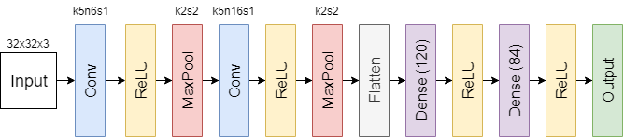

Figure 1. [LeCun, 1998] model

The second model takes 32 × 32 images in gray colors in 1 channel as an input, it has a more complex architecture, which the authors called "QuadroConvPoolNet", the architecture of the model is shown in Figure 2. This median model without fully connected layer is similar to [7], but with a later position of pooling and different filters.

The convolutional kernels, pooling layer 3-1-1-4-5 and all the convolutional layers use a stride of 1, the model takes about 1 MegaByte in memory.

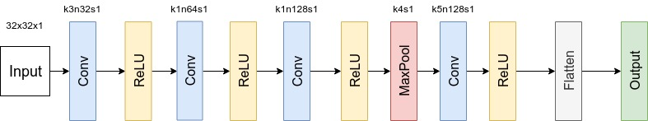

Figure 2. QuadroConvPoolNet

The third model was created by Murat Taskiran, Mehmet Killioglu and Nihan Kahraman [4], the architecture of the model is shown in   
Figure 3. [Taskiran et al. 2018] model. It takes 28 × 28 grayscale images as an input, the structure is like the first model, but convolutional layers have 3 × 3 kernel and the only one MaxPooling and one Dense layer.

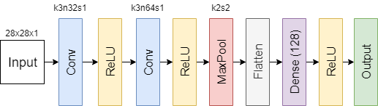

Figure 3. [Taskiran et al. 2018] model

The fourth model was created by Debasrita Chakraborty, Deepankar Garg, Ashish Ghosh and Jonathan H. Chan [5], the architecture of the model is shown in Figure 4. [Chakraborty et al. 2018] model. It has 4 convolutional layers with 1 × 1 kernels. Each of them, except the third one, is followed by a MaxPooling layer. At the end of the network features are flattened and SoftMax function is applied to predict class. Before training, the model was trained as autoencoder for finetuning weights for the Encoder part.

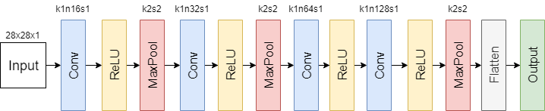

Figure 4. [Chakraborty et al. 2018] model

Table 1 presents the descriptive statistics of the results obtained and Table 2 presents the prediction accuracies (%) of static dactyls on the test sample for the four models. In our paper we use the transliteration of the letters of the Russian alphabet according to GOST-7.79-2000 (system B) [8]. The QuadroConvPoolNet can be considered as the best model, testing this model on the test data set gave the best results. This model has the highest minimum accuracy value, the highest maximum accuracy value, the highest overall accuracy, and the smallest standard deviation.

**Table 1** - Descriptive statistics of the obtained prediction accuracies

|  |  |  |  |  |
| --- | --- | --- | --- | --- |
|  | [LeCun, 1998] model | QuadroConvPoolNet model | [Taskiran et al. 2018] model | [Chakraborty et al. 2018] model |
| Count | 27 | 27 | 27 | 27 |
| Mean | 70.26% | 77.56% | 70.7% | 33.59% |
| Std | 13.02% | 8.82% | 10.97% | 11.2% |
| Min | 25% | 61% | 50% | 20% |
| 25% | 65% | 69% | 60% | 25.5% |
| 50% | 73% | 80% | 70% | 32% |
| 75% | 78.5% | 84.5% | 81% | 40% |
| Max | 89% | 93% | 87% | 65% |

**Table 2** - Accuracy on RSL test data

|  |  |  |  |  |  |  |
| --- | --- | --- | --- | --- | --- | --- |
| Letter | Transliteration | Transcription in the articles | [LeCun, 1998] model | QuadroConvPoolNet model | [Taskiran et al. 2018] model | [Chakraborty et al. 2018] model |
| А | A | a | 51% | 70% | 60% | 20% |
| Б | B | b | 65% | 75% | 68% | 22% |
| В | V | v | 75% | 86% | 70% | 27% |
| Г | G | g | 68% | 84% | 59% | 39% |
| Д | D | - | - | - | - | - |
| Е | Ye | e | 75% | 69% | 68% | 40% |
| Ё | Yo | - | - | - | - | - |
| Ж | Zh | zh | 70% | 83% | 71% | 28% |
| З | Z | - | - | - | - | - |
| И | I | i | 83% | 69% | 78% | 40% |
| Й | J | - | - | - | - | - |
| К | K | k | 83% | 86% | 84% | 33% |
| Л | L | l | 65% | 78% | 81% | 29% |
| М | M | m | 78% | 77% | 80% | 27% |
| Н | N | n | 76% | 82% | 60% | 24% |
| О | O | o | 79% | 80% | 81% | 21% |
| П | P | p | 65% | 61% | 60% | 20% |
| Р | R | r | 67% | 88% | 72% | 45% |
| С | S | s | 89% | 93% | 87% | 35% |
| Т | T | t | 68% | 69% | 65% | 65% |
| У | U | u | 82% | 88% | 83% | 40% |
| Ф | F | f | 85% | 82% | 85% | 43% |
| Х | X | kh | 55% | 80% | 60% | 45% |
| Ц | C | c | 25% | 87% | 50% | 25% |
| Ч | Ch | ch | 82% | 85% | 85% | 43% |
| Ш | Sh | sh | 62% | 62% | 60% | 55% |
| Щ | Shh | - | - | - | - | - |
| Ъ | `` | - | - | - | - | - |
| Ы | Y` | yi | 73% | 65% | 70% | 26% |
| Ь | ` | - | - | - | - | - |
| Э | E` | ye | 58% | 67% | 50% | 20% |
| Ю | Yu | yu | 69% | 69% | 68% | 30% |
| Я | Ya | ya | 76% | 81% | 83% | 32% |
| Overall |  |  | 73% | 78% | 71% | 33% |

1. DATASET

For our project, we needed a large RDA dataset that considers all the features of the recognition algorithm in the application, so we created it ourselves.

## Russian dactyl alphabet

RDA consists of 33 dactyl signs, 24 of which are static and 9 are dynamic. Some dactyls have similarities with the printed characters (G, L, M, O, S), others are reproductions in the air of the written alphabets (O, D, Z), the rest ones include separate conventional features of the written and printed letters. The dactyls’ look is shown in   
Table 3 and it is also indicated whether the dactyl is static or dynamic.

**Table 3** - Signs

|  |  |  |  |  |  |  |  |  |  |  |  |  |  |  |  |  |  |  |  |  |  |  |  |  |  |  |  |  |  |  |  |  |  |  |  |
| --- | --- | --- | --- | --- | --- | --- | --- | --- | --- | --- | --- | --- | --- | --- | --- | --- | --- | --- | --- | --- | --- | --- | --- | --- | --- | --- | --- | --- | --- | --- | --- | --- | --- | --- | --- |
| |  | | --- | | A (А) | |  | | | static | | |  | | --- | | B (Б) | |  | | | static | | |  | | --- | | V (В) | |  | | | static | | |  | | --- | | G (Г) | |  | | | static | | |  | | --- | | D (Д) | |  | | | dynamic | | |  | | --- | | Ye (Е) | |  | | | static | | |  | | --- | | Yo (Ё) | |  | | | dynamic | | |  | | --- | | Zh (Ж) | |  | | | static | | |  | | --- | | Z (З) | |  | | | static | |
| |  | | --- | | I (И) | |  | | | static | | |  | | --- | | J (Й) | |  | | | dynamic | | |  | | --- | | K (К) | |  | | | dynamic | | |  | | --- | | L (Л) | |  | | | static | | |  | | --- | | M (М) | |  | | | static | | |  | | --- | | N (Н) | |  | | | static | | |  | | --- | | O (О) | |  | | | static | | |  | | --- | | P (П) | |  | | | static | | |  | | --- | | R (Р) | |  | | | static | |
| |  | | --- | | S (С) | |  | | | static | | |  | | --- | | T (Т) | |  | | | static | | |  | | --- | | U (У) | |  | | | static | | |  | | --- | | F (Ф) | |  | | | static | | |  | | --- | | X (Х) | |  | | | static | | |  | | --- | | C (Ц) | |  | | | dynamic | | |  | | --- | | Ch (Ч) | |  | | | static | | |  | | --- | | Sh (Ш) | |  | | | static | | |  | | --- | | Shh (Щ) | |  | | | dynamic | |
| |  | | --- | | `` (Ъ) | |  | | | dynamic | | |  | | --- | | Y` (Ы) | |  | | | static | | |  | | --- | | ` (Ь) | |  | | | dynamic | | |  | | --- | | E` (Э) | |  | | | static | | |  | | --- | | Yu (Ю) | |  | | | static | | |  | | --- | | Ya (Я) | |  | | | static | |

## Dataset concept

For our project, we need a large dataset with all RSL dactyls, we use vectorized images to train our classifier model. For static dactyls, it is obvious that we need to collect images of each dactyl. For dynamic dactyls, this approach is not possible because they have many different positions in the showing process. I decided to analyze each dynamic dactyl and noticed that they can be divided into several groups:

1. Dactyls that do not have movement in the wrist joint when they are shown: Z (З), C (Ц), Shh (Щ).

2. Dactyls whose pointing involves movement at the wrist joint: D (Д), Yo (Ё), J (Й), K (К), `` (Ъ), ` (Ь).

The essential difference between these two groups is that if you take a series consecutive picture while showing dactyls of the first group, the hand will look the same in them, for the second group the hand will rotate and have different positions in different pictures.

Consider each dynamic dactyl of the first group:

1. Z (З) - dactyl Z has the same finger configuration as dactyl X, with the difference that the tip of the bent index finger describes the outlines of the capital Russian letter "З" during showing. The same images will be used for these dactyls (Figure 5), dactyl Z will be determined in the presence of the described trajectory of movement.

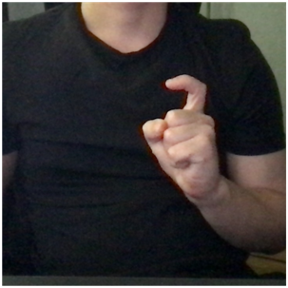

Figure 5. Dactyl ‘X’, ‘Z’

2. C (Ц) - dactyl C has a unique finger configuration, the hand shifts downward when shown. Figure 6 shows an example of an image for this dactyl.

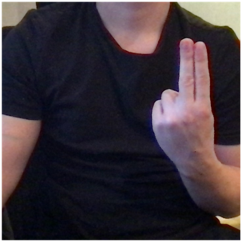

Figure 6. Dactyl 'C'

3. Shh (Щ) - dactyl Shh has the same finger configuration as dactyl Sh, with the difference that the hand shifts downward when shown. The same images will be used for these dactyls (Figure 7), dactyl Shh will be determined in the presence of the described trajectory of movement.

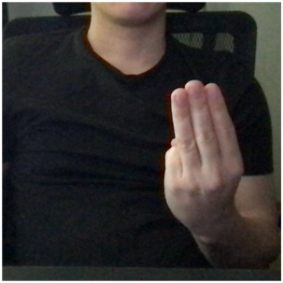

Figure 7. Dactyl 'Shh'

Consider each dynamic dactyl of the second group:

1.D (Д) - at the beginning of the movement the index and middle fingers are directed upwards, then the fingertips describe the contours of the capital letter «D», the trajectory is like a circle, the hand faces the back surface to the demonstrator. The movement is represented as four separate intermediate dactyls on the Figure 8.

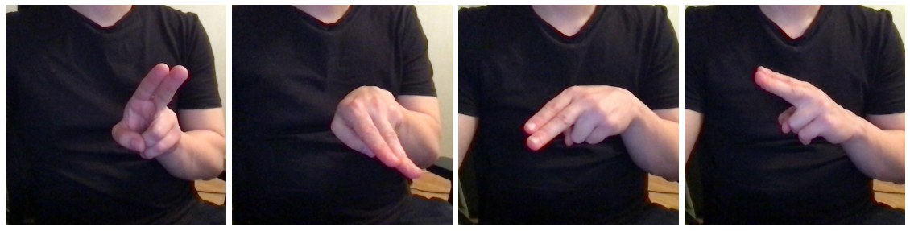

Figure 8. Dactyl ‘D’ frames

2. Yo (Ё) - at the beginning of the movement, the fingers are closed in a ring and turned toward the body, then the hand turns outward at the wrist joint, with the fingertips moving in a quarter circle. The movement is represented as three separate intermediate dactyls in Figure 9.

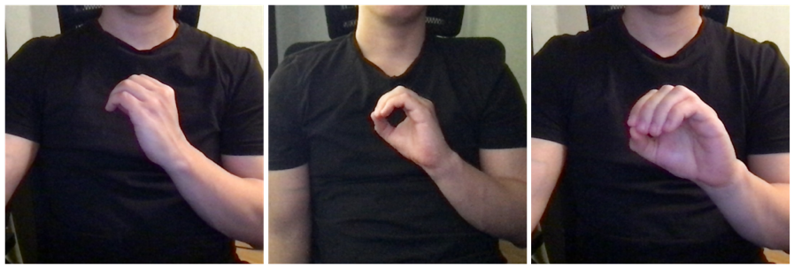

Figure 9. Dactyl 'Yo' frames

3. J (Й) - at the beginning of the movement, the ring finger and the little finger are extended, the thumb, the index and the middle fingers are closed in a ring and turned toward the body, then the wrist turns outward at the wrist joint, and the fingertips form a quarter circle. The movement is represented as three separates intermediate dactyls in Figure 10.

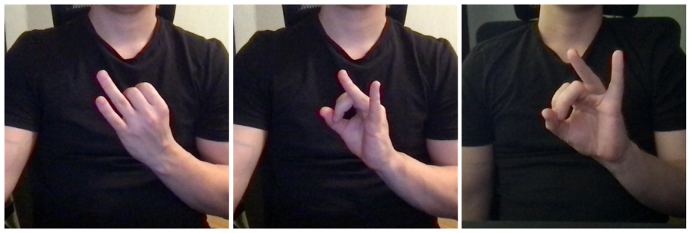

Figure 10. Dactyl 'J' frames

4. K (К) - at the beginning of the movement, the index and middle fingers are pointed upward, the hand is positioned with the edge of the palm toward the viewer, and then there is a distraction at the wrist joint and the index and the middle fingers are directed toward the viewer. Figure 11 shows this movement as two separate intermediate dactyls.

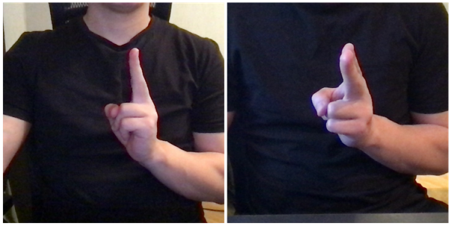

Figure 11. Dactyl 'K' frames

5. `` (Ъ) - at the beginning of the movement, the index finger is pointed straight forward, and the hand is palm down, then there is a rotation at the wrist joint and the hand is flipped palm up. Figure 12 shows this movement as three separate intermediate dactyls. The same images are used for `` and `, the recognition considers the trajectory of the index finger, if there was a shift to the outside, `` is detected.

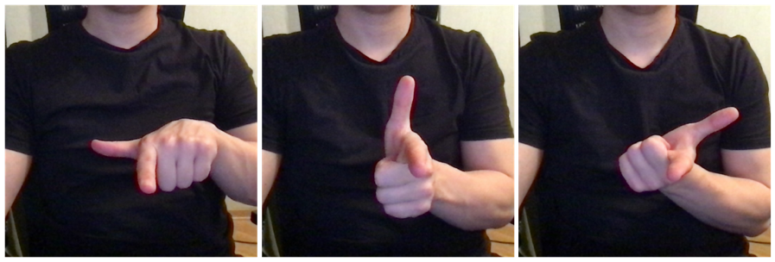

Figure 12. Dactyl '``' frames

6. ` (Ь) - at the beginning of the movement, the index finger is pointed straight forward, and the hand is palm up, then there is a rotation at the wrist joint and the hand is flipped palm down. Figure 13 shows this movement as three separate intermediate dactyls. The same images are used for `` and `, the recognition considers the trajectory of the index finger, and if there was a shift to the inside, ` is detected.

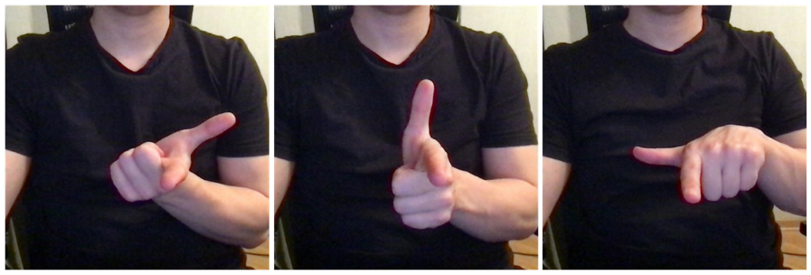

Figure 13. Dactyl '`' frames

## Test dataset creation

There were created dataset [1], which contains dactyls from seven people. The test dataset contains images of two people. In addition to the original images, there are augmented images: each image was modified in four different ways:

* horizontal compression by 10%
* horizontal stretching by 10%
* vertical compression by 20%
* vertical stretching by 20%

The test dataset contains 15149 images, whole dataset contains 62469 images. The models were tested on data that were not used during its training. An example of images from the test dataset is shown in Figure 14.

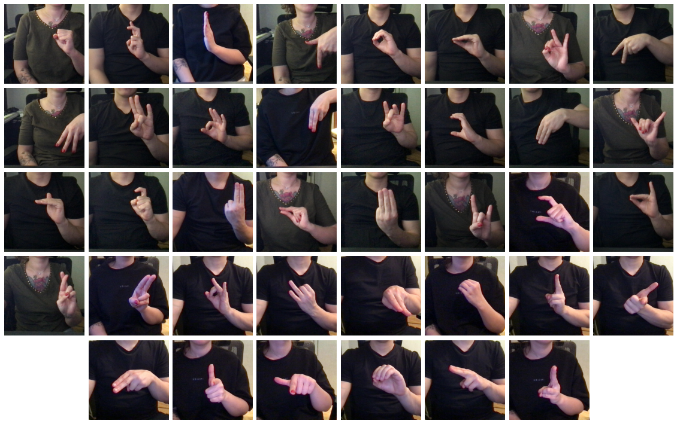

Figure 14. RDA test dataset examples

# PIPELINE

## Hand pose estimation and landmarks

For our model we use vectorized images.

The first step is getting coordinates of hand points from the image using MediaPipe Hands [9], which consists of two models: Palm Detection Model and Hand Landmark Model. Palm Detection Model finds the hand in the image, here is a description: «To detect initial hand locations, we designed a [single-shot detector](https://arxiv.org/abs/1512.02325) model optimized for mobile real-time uses in a manner similar to the face detection model in [MediaPipe Face Mesh](https://google.github.io/mediapipe/solutions/face_mesh.html). Detecting hands is a decidedly complex task: our [lite model](https://github.com/google/mediapipe/tree/master/mediapipe/modules/palm_detection/palm_detection_lite.tflite) and [full model](https://github.com/google/mediapipe/tree/master/mediapipe/modules/palm_detection/palm_detection_full.tflite) have to work across a variety of hand sizes with a large scale span (~20x) relative to the image frame and are able to detect occluded and self-occluded hands. Whereas faces have high contrast patterns, e.g., in the eye and mouth region, the lack of such features in hands makes it comparatively difficult to detect them reliably only from their visual features. Instead, providing additional context, like arm, body, or person features, aids accurate hand localization. Our method addresses the above challenges using different strategies. First, we train a palm detector instead of a hand detector, since estimating bounding boxes of rigid objects like palms and fists is significantly simpler than detecting hands with articulated fingers. In addition, as palms are smaller objects, the non-maximum suppression algorithm works well even for two-hand self-occlusion cases, like handshakes. Moreover, palms can be modelled using square bounding boxes (anchors in ML terminology) ignoring other aspect ratios, and therefore reducing the number of anchors by a factor of 3-5. Second, an encoder-decoder feature extractor is used for bigger scene context awareness even for small objects (like the RetinaNet approach). Lastly, we minimize the focal loss during training to support many anchors resulting from the high scale variance.

With the above techniques, we achieve an average precision of 95.7% in palm detection. Using a regular cross entropy loss and no decoder gives a baseline of just 86.22%. » [10]

Then Hand Landmark Model takes the found frame and returns highly accurate three-dimensional key points of the hand, here is a description: «After the palm detection over the whole image our subsequent hand landmark [model](https://github.com/google/mediapipe/tree/master/mediapipe/modules/hand_landmark/hand_landmark_full.tflite) performs precise keypoint localization of 21 3D hand-knuckle coordinates inside the detected hand regions via regression, that is direct coordinate prediction. The model learns a consistent internal hand pose representation and is robust even to partially visible hands and self-occlusions. To obtain ground truth data, we have manually annotated ~30K real-world images with 21 3D coordinates, as shown below (we take Z-value from image depth map, if it exists per corresponding coordinate). To cover the possible hand poses better and provide additional supervision on the nature of hand geometry, we also render a high-quality synthetic hand model over various backgrounds and map it to the corresponding 3D coordinates. » [11]

The obtained hand points are shown in Figure 15. An example of how MediaPipe Hands works is shown in Figure 16.

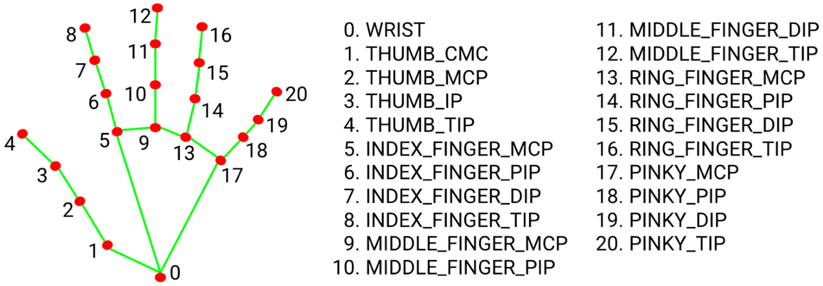

Figure 15. Hand points defined by MediaPipe Hands

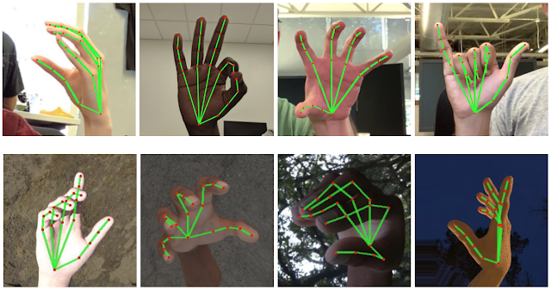

Figure 16. An example of how MediaPipe Hands works

## Feature generation

My colleague Olga Vasilyeva created the algorithm to vectorize the output data into features. As mentioned above, the MediaPipe Hands output data are 21 points in three-dimensional space, that is, coordinates of points on the x, y, z axes. The idea of the algorithm is to measure distances between those points where anatomically a significant distance change is possible, the distances are measured between the following points: 0 and 2, 3, 4, 6, 7, 8, 10, 11, 12, 14, 15, 16, 18, 19, 20; 3 and 6, 10, 14, 18; 4 and 8, 12, 16, 20; 6 and 10, 14, 18; 8 and 12, 16, 20; 10 and 14, 18; 12 and 16, 20; 14 and 18, 16 and 20.

The points and distances are shown in Figure 17. These distances are then normalized, so that it becomes irrelevant whether the hand is closer to the camera or farther away. Then, using the coordinates of points 0, 5, and 17, six additional features are generated that determine the position of the hand in space. A total of 41 features are obtained for each image, and we train and test the classifier model on these features.

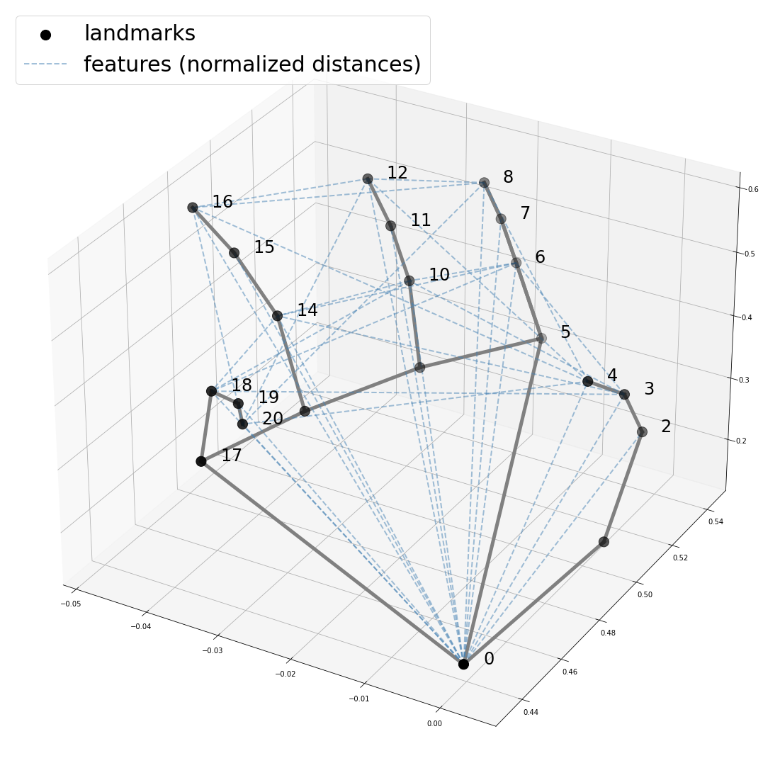

Figure 17. Features

## Model selection for dactyls classification

We need another model to predict the class, the task is a multiclass classification. In this work were analyzed three models: Logistic Regression [12], Decision Tree Classifier [13], Multi-layer Perceptron with two hidden layers. For each model, except Multi-layer Perceptron, the best hyperparameters were selected using GridSearchCV [14], it is an automated tool to find the best hyperparameters for a model by a given metric using crossvalidation. Learning time, prediction time, overall accuracy, and standard deviation were considered in selecting the best model, the best model is Logistic Regression.

The models used are shown below:

1. LogisticRegression  
     
   {  
    **'C'**: 3, **'class_weight'**: **'balanced'**, **'dual'**: **False**,   
    **'fit_intercept'**: **True**, **'intercept_scaling'**: 1,   
    **'l1_ratio'**: **None**, **'max_iter'**: 100, **'multi_class'**: **'auto'**,   
    **'n_jobs'**: -1, **'penalty'**: **'l1'**, **'random_state'**: 42,  
    **'solver'**: **'liblinear'**, **'tol'**: 0.0001,   
    **'verbose'**: 0, **'warm_start'**: **False**}

1. DecisionTreeClassifier  
     
   {  
    **'ccp_alpha'**: 0.0, **'class_weight'**: **'balanced'**,   
    **'criterion'**: **'gini'**, **'max_depth'**: **None**,   
    **'max_features'**: **None**, **'max_leaf_nodes'**: **None**,  
    **'min_impurity_decrease'**: 0.0, **'min_samples_leaf'**: 2,  
    **'min_samples_split'**: 2, **'min_weight_fraction_leaf'**: 0.0,  
    **'random_state'**: 42, **'splitter'**: **'best'**}
2. MLP with two hidden layers                                                
   This model has four linear layers [15], activation functions are PReLU [16] and the last one is SoftMax [17], loss function is Cross Entropy [18], optimizer is Stochastic Gradient Descent [19], epoch number equals to 5, learning rate equals to 0.01, batch size equals to 16. The network architecture is shown in Figure 18.

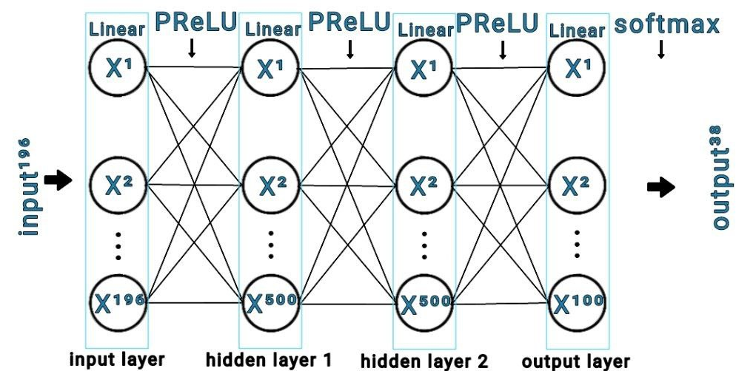  
*Figure 18. MLP Architecture*

Dactyl prediction overall accuracies on cross validation and test sample, fitting and predicting times are shown in Table4, descriptive statistics are shown in   
Table 5, accuracies of each model for each dactyl are shown in Table 6. The best model is Logistic Regression, it has the highest accuracy on cross validation, the highest accuracy on the test sample, the smallest standard deviation, that is the most stable classifies different dactyls, the prediction time is one of the smallest.

**Table 4** - Model comparison

|  |  |  |  |  |
| --- | --- | --- | --- | --- |
|  | Accuracy on cross-val | Accuracy on test | Fitting time (sec.) | Predicting time (sec.) |
| LogisticRegression | 94.84% | 95.75% | 668.02 | 0.02 |
| MLP | **-** | 93.54% | 71.31 | 4.41 |
| DecisionTreeClassifier | 86.77% | 88.19% | 2.42 | 0.01 |

**Table 5** - Models accuracies descriptive statistics

|  |  |  |  |
| --- | --- | --- | --- |
|  | Logistic Regression | Decision Tree Classifier | MLP |
| count | 33.00 | 33.00 | 33.00 |
| mean | 95.75% | 88.19% | 93.54% |
| std | 6.67% | 12.99% | 13.89% |
| min | 75.00% | 57.60% | 24.20% |
| 25% | 95.40% | 75.20% | 94.20% |
| 50% | 98.00% | 94.39% | 97.80% |
| 75% | 100.00% | 98.60% | 100.00% |
| max | 100.00% | 100.00% | 100.00% |

**Table 6** - Accuracy results

|  |  |  |  |  |
| --- | --- | --- | --- | --- |
| Letter of the RDA | Transliteration | Logistic Regression | LGBM Classifier | MLP |
| А | A | 100.0% | 100.0% | 99.0% |
| Б | B | 91.4% | 91.6% | 86.4% |
| В | V | 100.0% | 100.0% | 100.0% |
| Г | G | 89.4% | 98.4% | 96.2% |
| Д | D | 81.51% | 85.48% | 85.63% |
| Е | Ye | 75.4% | 98.4% | 88.8% |
| Ё | Yo | 95.3% | 92.9% | 93.7% |
| Ж | Zh | 96.0% | 99.2% | 99.4% |
| З | Z | 96.4% | 99.0% | 96.0% |
| И | I | 91.0% | 67.8% | 24.2% |
| Й | J | 94.4% | 88.4% | 90.8% |
| К | K | 75.0% | 75.7% | 70.8% |
| Л | L | 96.2% | 93.8% | 94.2% |
| М | M | 99.2% | 98.6% | 99.0% |
| Н | N | 100.0% | 100.0% | 100.0% |
| О | O | 100.0% | 100.0% | 100.0% |
| П | P | 98.0% | 85.6% | 87.8% |
| Р | R | 100.0% | 99.8% | 100.0% |
| С | S | 100.0% | 99.8% | 100.0% |
| Т | T | 95.6% | 87.4% | 96.4% |
| У | U | 100.0% | 100.0% | 99.8% |
| Ф | F | 100.0% | 100.0% | 99.8% |
| Х | X | 96.4% | 99.0% | 96.0% |
| Ц | C | 100.0% | 100.0% | 100.0% |
| Ч | Ch | 100.0% | 98.6% | 97.8% |
| Ш | Sh | 100.0% | 100.0% | 100.0% |
| Щ | Shh | 100.0% | 100.0% | 100.0% |
| Ъ | `` | 95.4% | 95.6% | 95.67% |
| Ы | Y` | 98.0% | 87.8% | 98.2% |
| Ь | ` | 95.4% | 95.6% | 95.67% |
| Э | E` | 100.0% | 100.0% | 100.0% |
| Ю | Yu | 99.8% | 100.0% | 95.8% |
| Я | Ya | 100.0% | 84.2% | 99.8% |
| Overall |  | 95.75% | 94.63% | 93.54% |

The test sample consists of original images and augmented images, it is necessary to check the quality of the model separately on each part of the sample. The results of the test are presented in   
Table ***7***. According to the descriptive statistics, we can see that the overall accuracy for the original images and the overall accuracy for the augmented images are almost the same, and the standard deviations are almost the same. It can be concluded that the model classifies well not only the original images, but also the compressed or stretched images, thus, it can be assumed that the model will work equally well on the new test data.

**Table 7** - Models accuracies descriptive statistics

|  |  |  |
| --- | --- | --- |
|  | Original images | Images with augmentation |
| count | 33 | 33 |
| mean | 96.36% | 95.59% |
| std | 6.98% | 6.65% |
| min | 71.00% | 75.00% |
| 25% | 97.0% | 94.83% |
| 50% | 100.00% | 100.00% |
| 75% | 100.00% | 100.00% |
| max | 100.00% | 100.00% |

## Results comparison and selection of the best model

My colleague Olga Vasilyeva analyzed 3 models: Random Forest Classifier [20], C-Support Vector Classification [21] and LightGBM Classifier [22]. Learning time, prediction time, overall accuracy, and standard deviation were considered in selecting the best model, the best model is Random Forest Classifier.

We compared the results obtained by Logistic Regression and Random Forest Classifier, descriptive statistics of the obtained accuracies are presented in Table 8. The overall accuracy of Linear Regression is higher, the standard deviation is lower, Logistic Regression was chosen as the best model and will be used in the application.

**Table 8** - Comparison results

|  |  |  |
| --- | --- | --- |
|  | Logistic Regression | Random Forest Classifier |
| count | 33.00 | 33.00 |
| mean | 95.75% | 95.06% |
| std | 6.67% | 7.94% |
| min | 75.00% | 71.40% |
| 25% | 95.40% | 94.80% |
| 50% | 98.00% | 98.40% |
| 75% | 100.00% | 100.00% |
| max | 100.00% | 100.00% |

1. TESTING THE MODELS UNDER DIFFERENT CONDITIONS

It is necessary to investigate the performance of the models under different conditions, such as the distance between the user and the camera, the level of illumination, the rotation of the user's hand, and the color of the background.

## Distance

My colleague Olga Vasilyeva investigated the possibility of hand detection and recognition of dactyls from different distances, the following distances in centimeters (distance between the webcam and the hand) were investigated:

* 400 cm, accuracy is 0%
* 300 cm, accuracy is 0%
* 250 cm, accuracy is 9%
* 200 cm, accuracy is 89%
* 150 cm, accuracy is 99%
* 100 cm, accuracy is 96%
* 80 cm, accuracy is 100%
* 60 cm, accuracy is 100%
* 50 cm, accuracy is 98%
* 40 cm, accuracy is 100%
* 30 cm, accuracy is 100%
* 20 cm, accuracy is 95%

There are 100 observations for each distance. It is acceptable to use models when the distance between the user's hand and the webcam is between 20 and 200 centimeters, the optimal distance is between 30 and 150 centimeters. With greater distances between the user's hand and the camera, there are both difficulties in detecting the hand and difficulties in correctly classifying the dactyls.

## Illumination level

My colleague Olga Vasilyeva investigated the possibility of hand detection and recognition of dactyls at different illumination levels was investigated, the following illumination levels in lux were investigated:

* 3 lux, accuracy is 78%
* 10 lux, accuracy is 100%
* 15 lux, accuracy is 100%
* 30 lux, accuracy is 100%
* 50 lux, accuracy is 100%
* 80 lux, accuracy is 100%
* 100 lux, accuracy is 100%
* 300 lux, accuracy is 100%
* 500 lux, accuracy is 79%
* 650 lux, accuracy is 68%
* 800 lux, accuracy is 5%
* 1000 lux, accuracy is 0%

There are 100 observations for each level of illumination. The illumination level is measured in lux, the higher the value, the brighter the place where the user is. It is acceptable to use the models when the light level is between 3 and 500 lux, that is, from a low level of light, such as light from a night light to a medium level of light, such as daylight. The optimal light level is 10 to 300 lux. When very bright light is directed at the user, the image becomes glitzy. Based on the results obtained, it can be said that at high light levels it is difficult to detect the hand.

## Rotation

The possibility of recognizing dactyls at different turns of the hand was investigated, turns in a circle with a step of 15 degrees were investigated. There are 250 observations for each turn.

The test results are shown in Table 9, examples of images obtained from different distances are shown in Figure 19.

**Table 9** - Rotation sensitivity

|  |  |
| --- | --- |
| Angle (degree) | Dactyl recognition accuracy |
| 0 | 100.0% |
| 15 | 96.4% |
| 30 | 76.0% |
| 45 | 27.2% |
| 60 | 3.6% |
| 75 | 0% |
| 90 | 0% |
| 105 | 0% |
| 120 | 0% |
| 135 | 0% |
| 150 | 0% |
| 165 | 0% |
| 180 | 0% |
| -165 | 0% |
| -150 | 0% |
| -135 | 0% |
| -120 | 0% |
| -105 | 0% |
| -90 | 1.6% |
| -75 | 6.4% |
| -60 | 68.4% |
| -45 | 95.6% |
| -30 | 100% |
| -15 | 100% |

|  |  |  |  |  |  |  |  |  |  |  |  |
| --- | --- | --- | --- | --- | --- | --- | --- | --- | --- | --- | --- |
| |  | | --- | |  | | | | 0° | | |  | | --- | |  | | | | -15° | | |  | | --- | |  | | | | -30° | | |  | | --- | |  | | | | -45° | |
| |  | | --- | |  | | | | -60° | | |  | | --- | |  | | | | -75° | | |  | | --- | |  | | | | -90° | | |  | | --- | |  | | | | -105° | |
| |  | | --- | |  | | | | -120° | | |  | | --- | |  | | | | -135° | | |  | | --- | |  | | | | -150° | | |  | | --- | |  | | | | -165° | |
| |  | | --- | |  | | | | 180° | | |  | | --- | |  | | | | 165° | | |  | | --- | |  | | | | 150° | | |  | | --- | |  | | | | 135° | |
| |  | | --- | |  | | | | 120° | | |  | | --- | |  | | | | 105° | | |  | | --- | |  | | | | 90° | | |  | | --- | |  | | | | 75° | |
| |  | | --- | |  | | | | 60° | | |  | | --- | |  | | | | 45° | | |  | | --- | |  | | | | 30° | | |  | | --- | |  | | | | 15° | |
|  |  |  |  |

Figure 19. Rotation examples

From the results obtained follows that turning the hand by 30 degrees to either side of the correct hand position when showing a dactyl is acceptable, it is optimal not to change the position by more than 15 degrees to either side. According to the results, follows that if the position of the hand differs significantly from the correct position, there are difficulties in recognizing dactyls. It is important to note that there are correct ways to show each dactyl, so low accuracy with too much change in hand position is more of a user error than a model, the user should be able to show the dactyl correctly.

## Color of clothes (background)

My colleague Olga Vasilyeva investigated the possibility of hand detection and recognition of dactyls in different backgrounds was investigated, the following background colors were investigated:

* black, accuracy is 99%
* beige, accuracy is 100%
* bright multicolored, accuracy is 80%

There are 100 observations for each background. It is better to use the models while wearing monochrome clothing. This rule is relevant not only for working with the application, but also sign language interpreters should wear monochrome clothes while working, as it is more difficult for the eye to recognize a dactyl on a multicolored background.

1. APPLICATION

## Application description

The application is presented as a web service written in python [23] programming language and FastAPI [24] as web framework. The application has three pages:

* On the first page, the app predicts the dactyl shown by the user through the webcam
* On the second page, the application checks the correctness of the shown dactyl
* On the third page, the app selects a random word from a list of popular Russian words and waits for its input using dactyls

A scheme of the application working is shown in the Figure 20.

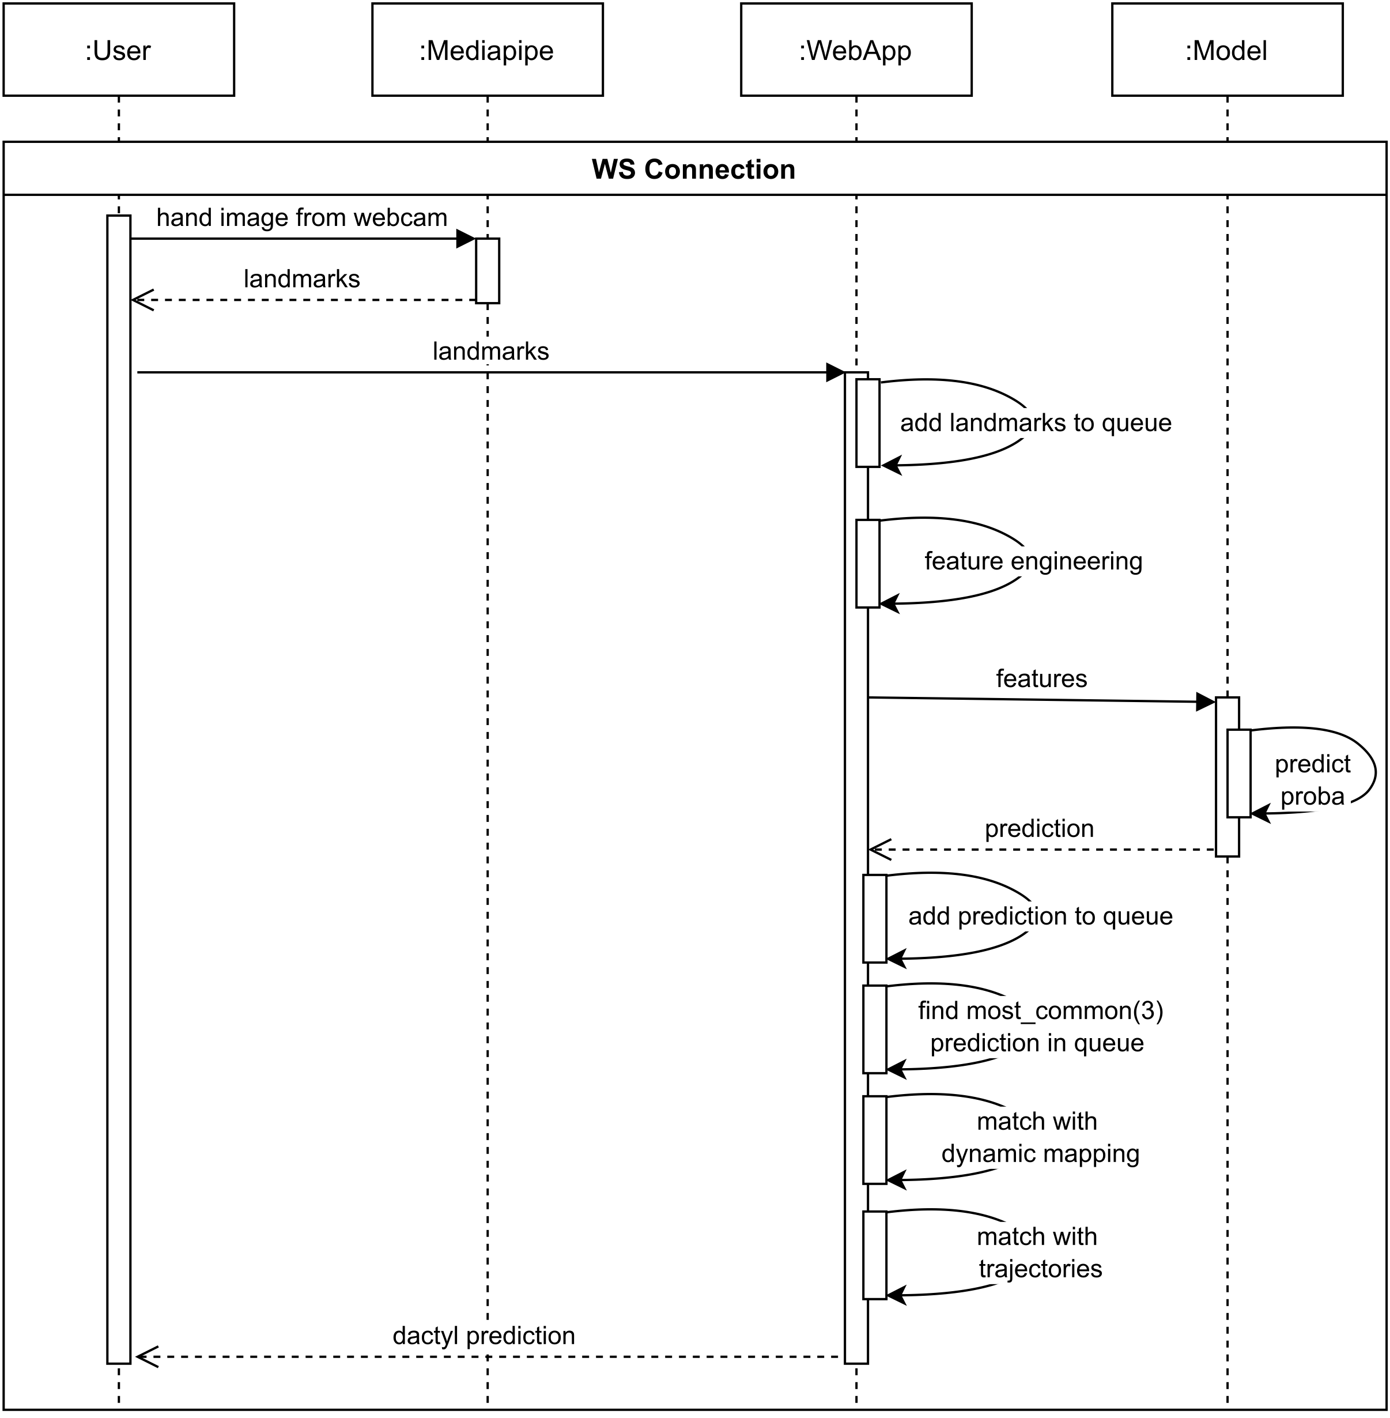

Figure 20. Sequence diagram

## Application flow

1. The image from the webcam is loaded to MediaPipe Hands.
2. MediaPipe Hands returns the prediction as the coordinates of 21 points in three-dimensional space, each point is an anatomical entity of the hand.
3. The coordinates will be sent to the web application.
4. The web application generates features from the coordinates using the author's algorithm.
5. At the same time the web application takes the coordinates of the index fingertip, and places it in the index finger coordinate queue.
6. Next, the web application sends features to the Logistic Regression model.
7. The model returns the class prediction and class membership probability
8. If the probability is greater than threshold, this prediction is placed in the queue of possible predictions.
9. The web application then calculates the trajectory based on the data in the queue with the fingertip coordinates: takes the first (x1, y1, z1) and the last (x2, y2, z2) elements from the queue and finds two numbers sign(x1 - x2), sign(y1 - y2), where a sign has a function of finding the sign of the number with minimal threshold. Possible values are:
   * (0, 0) — no shift
   * (1, 0) — shift on x-axis to the right
   * (-1, 0) — shift on x-axis to the left
   * (0, 1) — downward shift on y-axis
   * (0, -1) — upward shift on y-axis

(1, 1), (-1, -1), (1, -1), (-1, 1) — combinations of the previous options.

1. The obtained value is put in the queue of possible trajectories.
2. Counter is created from the queue of possible predictions and from this counter the web application gets three most common predictions.
3. Next, the web application runs through the possible mappings from the dynamic dactyl settings.

DYNAMIC = {  
 'D': [  
 {'D1', 'D2'},  
 {'D1', 'D3'},  
 {'D1', 'D4'},  
 {'D2', 'D3'},  
 {'D2', 'D4'},  
 {'D3', 'D4'},  
 ],  
 'Yo': [  
 {'Ye', 'Yo1'},  
 {'Ye', 'Yo2'},  
 {'Yo1', 'Yo2'},  
 ],  
 'J': [  
 {'I', 'J1'},  
 {'I', 'J2'},  
 {'J1', 'J2'},  
 ],  
 'K': [  
 {'K1', 'K2'}  
 ],  
 '```': [  
 {'```1', '```2'},  
 {'```1', '```3'},  
 {'```2', '```3'},  
 ]  
}

1. If three most common ones have any of two predicted dactyls that are specified in the mapping, then the web application assumes that it is one of the dynamic dactyls. If there is no such mapping, it takes one most common sign from the queue of possible predictions as the predicted dactyl.
2. Next, the web application takes the most_common(1) trajectory from the trajectory queue.
3. After it match the trajectory and the previously predicted dactyl, to find a dynamic, e. g. Sh to Ssh:

DYNAMIC_MAPPING = {  
 ('Sh', (0, -1)): 'Ssh',  
 ('X', (0, -1)): 'Z',  
 ('X', (1, -1)): 'Z',  
 ('', (1, 1)): '`',  
 ('```', (1, 0)): '``',  
 ('```', (-1, 1)): '`',  
 ('```', (-1, 0)): '`',  
}

1. If no mapping is found, the web application thinks the dactyl is static.

## Application operation modes

### Simple detection and classification mode

The first mode of the application is a simple detection and classification of dactyls. As you can see in Figure 21, if there is no hand in front of the camera, detection and classification do not take place, there is no letter in the block with the output. As seen in Figure 22, a hand appeared in front of the camera, the finger configuration is dactyl B, the letter B appeared in the output block. As seen in Figure 23, a hand appeared in front of the camera, the finger configuration does not match any of the dactyls, there is no letter in the output block.

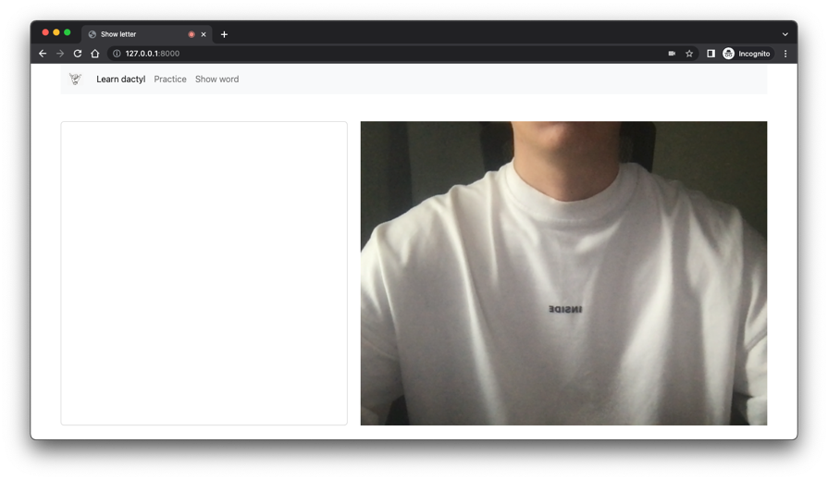

Figure 21. No hand in front of camera

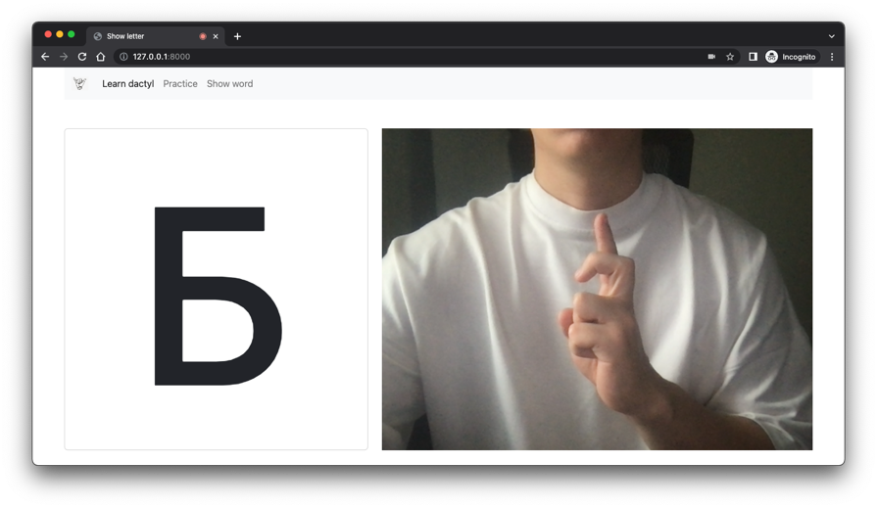

Figure 22. Dactyl B

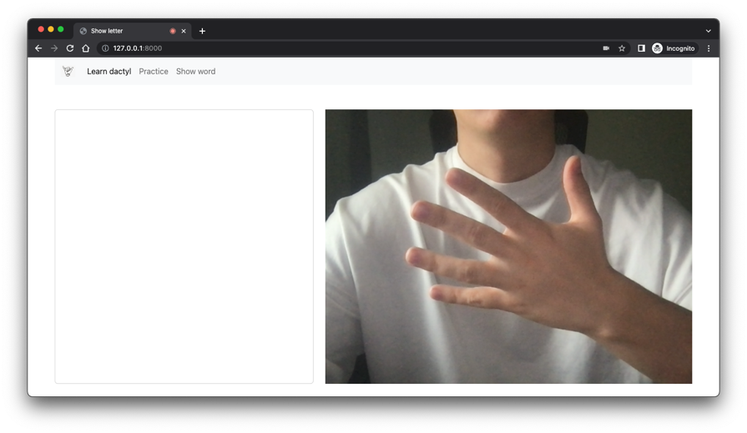

Figure 23. No dactyl, random configuration of fingers in front of the camera

### Correct dactyl mode

The second mode of the application is the mode of checking the correctness of the shown dactyl. A letter from the RDA is randomly selected, then this letter appears in the output block. As we can see in Figure 24, the dactyl Y is expected, but the user shows dactyl A, that is not the dactyl that is expected, the correctness indicator does not work. The user has the option to request a hint, as we can see in Figure 25, the image of dactyl Y appears in the output block. After the user shows the expected dactyl correctly, the correctness indicator highlights the output block in green, the result is shown in Figure 26.

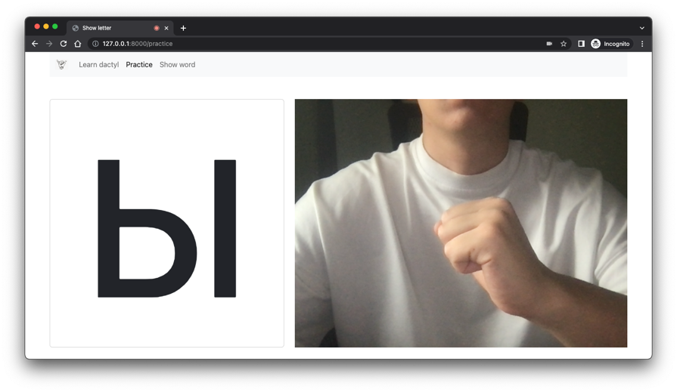

Figure 24. User shows wrong dactyl

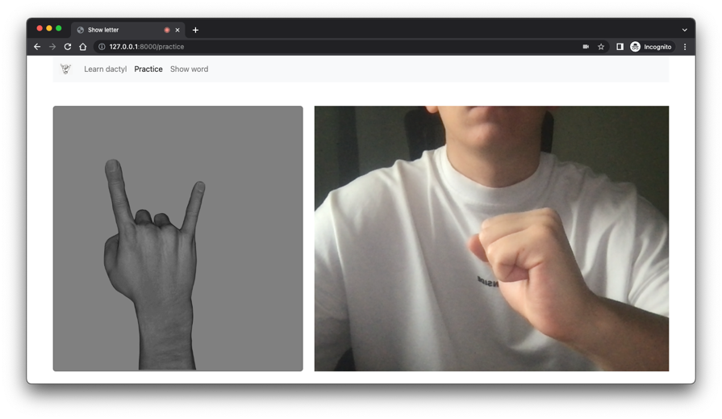

Figure 25. User asks for hint

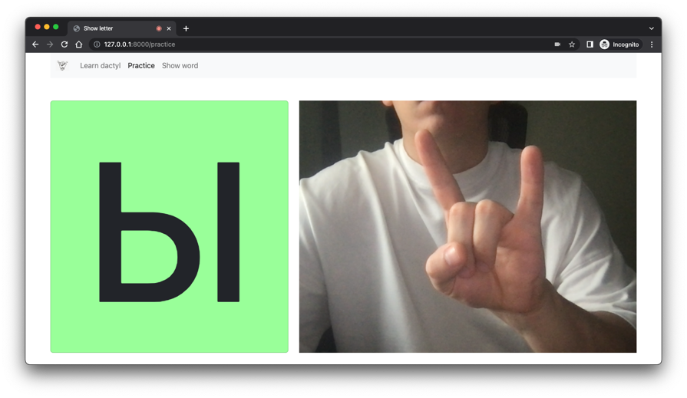

Figure 26. User shows correct dactyl

### Word guessing mode

My colleague Olga Vasilyeva developed the third mode of the application which is word guessing mode. In this mode, the user needs to guess the word shown in the pictures and write it letter by letter using dactyl. An example of the operation of this mode is shown in Figure 27.

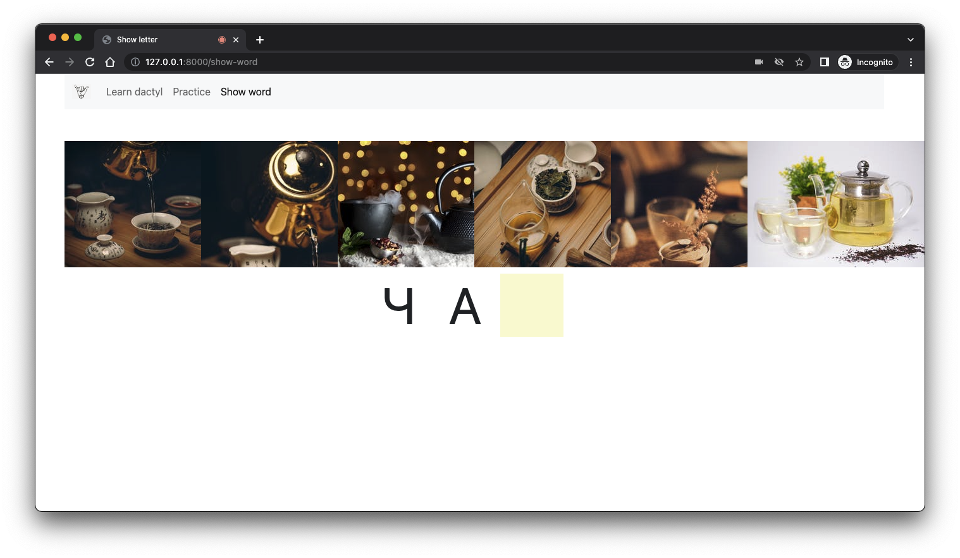

Figure 27. User inputs word letter by letter using dactyls

CONCLUSION

The goal of our project was to implement recognition of all the dactyls of RSA and obtain a higher overall accuracy with a smaller standard deviation. Since there are dynamic dactyls, this is only possible with recognition from a video. We have successfully achieved our goal and made the application to make our project complete.   
Table 10 has descriptive statistics for the recognition accuracies of the dactyls, the first column shows the results for 26 dactyls (24 of which are static and 2 dynamics, but presented as static) using the QuadroConvPoolNet model, which previously gave the best result [2]. The second column shows the results for these 26 dactyls using the current approach (MediaPipe Hands, Logistic Regression and author's algorithms), the third column shows the results for 7 remaining dactyls using the current approach.

**Table 10** - Descriptive statistics of dactyl prediction accuracies

|  |  |  |  |
| --- | --- | --- | --- |
|  | QuadroConvPoolNet, static dactyls and two dynamic dactyls represented as static | Current approach, static dactyls and two dynamic dactyls | Current approach, other dynamic dactyls |
| count | 26 | 26 | 7 |
| mean | 77.53% | 96.08% | 93.71% |
| std | 8.99% | 6.97% | 5.94% |
| min | 61.00% | 75.00% | 81.00% |
| 25% | 69.00% | 96.00% | 94.50% |
| 50% | 80.00% | 99.50% | 95.00% |
| 75% | 84.75% | 100.00% | 95.5% |
| max | 93.00% | 100.00% | 100% |

We got the following results: average accuracy increased by 18.55%, standard deviation decreased by 2.02%, minimum accuracy increased by 14%, maximum accuracy increased by 7% to 100%. We believe that we achieved our goal and got great results. In the future, it is possible to implement dactyl recognition for other sign languages and to implement word recognition for sign languages using our approach.

REFERENCES

1. I. Makarov, N. Veldyaykin, M. Chertkov, and A. Pokoev. 2019. “American and Russian Sign Language Dactyl Recognition”, in: Proceedings of the 12th ACM Conference on PErvasive Technologies Related to Assistive Environments (PETRA’19). NY: ACM, 2019. P. 204-210. // <https://dl.acm.org/doi/10.1145/3316782.3316786>
2. I. Makarov, N. Veldyaykin, M. Chertkov, and A. Pokoev. 2019. “Russian Sign Language Dactyl Recognition”, in: 2019 42nd International Conference on Telecommunications and Signal Processing (TSP). NY: IEEE, 2019. P. 726-729. // <https://ieeexplore.ieee.org/document/8768868>
3. I. Makarov, N. Veldyaykin, M. Chertkov, and A. Pokoev. 2019. “American and Russian Sign Language Dactyl Recognition and Text2Sign Translation in Analysis of Images”, in: Analysis of Images, Social Networks and Texts. 8th International Conference AIST 2019. Springer, 2019. P. 309-320. // <https://dl.acm.org/doi/abs/10.1007/978-3-030-37334-4_28>
4. Murat Taskiran, Mehmet Killioglu, and Nihan Kahraman. 2018. “A Real-Time System for Recognition of American Sign Language by using Deep Learning”, in: 2018 41st International Conference on Telecommunications and Signal Processing (TSP). IEEE, IEEE, New York, NY, USA, 2018. P. 1–5. // <https://ieeexplore.ieee.org/document/8441304>
5. Debasrita Chakraborty, Deepankar Garg, Ashish Ghosh, and Jonathan H. Chan. 2018. “Trigger Detection System for American Sign Language using Deep Convolutional Neural Networks”, in: Proceedings of the 10th International Conference on Advances in Information Technology. ACM, ACM DL, New York, NY, USA, 2018. P. 1-6. // <https://dl.acm.org/doi/10.1145/3291280.3291783>
6. Yann LeCun, Léon Bottou, Yoshua Bengio, and Patrick Haffner. 1998. “Gradient based learning applied to document recognition”. Proc. IEEE 86, 11 (1998). P. 2278– 2324. // <https://ieeexplore.ieee.org/document/726791>
7. G. Rao, K. Syamala, P. Kishore, and A. Sastry. 2018. “Deep convolutional neural networks for sign language recognition”, in: Signal Processing and Communication Engineering Systems (SPACES), 2018 Conference on. IEEE, IEEE, New York, NY, USA, P. 194–197. // <https://ieeexplore.ieee.org/abstract/document/8316344>
8. Transliteration of Russian alphabet, GOST-7.79-2000 (system B) // <http://transliteration.ru/gost-7-79-2000>
9. MediaPipe Hands // <https://google.github.io/mediapipe/solutions/hands>
10. MediaPipe Palm Detection Model // <https://google.github.io/mediapipe/solutions/hands#palm-detection-model>
11. MediaPipe Hand Landmark Model // <https://google.github.io/mediapipe/solutions/hands#hand-landmark-model>
12. Logistic Regression // <https://scikit-learn.org/stable/modules/generated/sklearn.linear_model.LogisticRegression.html>
13. Decision Tree Classifier // <https://scikit-learn.org/stable/modules/generated/sklearn.tree.DecisionTreeClassifier.html>
14. Grid Search CV // <https://scikit-learn.org/stable/modules/grid_search.html>
15. Linear layer // <https://pytorch.org/docs/stable/generated/torch.nn.Linear.html>
16. Activation function PReLU // <https://pytorch.org/docs/stable/generated/torch.nn.PReLU.html>
17. Activation function SoftMax // <https://pytorch.org/docs/stable/generated/torch.nn.functional.softmax.html>
18. Cross Entropy Loss function // <https://pytorch.org/docs/stable/generated/torch.nn.CrossEntropyLoss.html>
19. Stochastic Gradient Descent // <https://pytorch.org/docs/stable/generated/torch.optim.SGD.html>
20. Random Forest Classifier // <https://scikit-learn.org/stable/modules/generated/sklearn.ensemble.RandomForestClassifier.html>
21. C-Support Vector Classification // <https://scikit-learn.org/stable/modules/generated/sklearn.svm.SVC.html>
22. LightGBM Classifier // <https://lightgbm.readthedocs.io/en/latest/pythonapi/lightgbm.LGBMClassifier.html>
23. Python Programming Language // <https://www.python.org/>
24. FastAPI // <https://fastapi.tiangolo.com/>
25. Pixels API // <https://api.pexels.com>

APPLICATIONS

1. Dataset // <https://github.com/timaakulich/diploma-applications/tree/master/dataset>
2. Web application source code // <https://github.com/timaakulich/diploma>